**Agile and Jira project (Shohoz.com)**

1. Go to the URL <https://www.shohoz.com/>

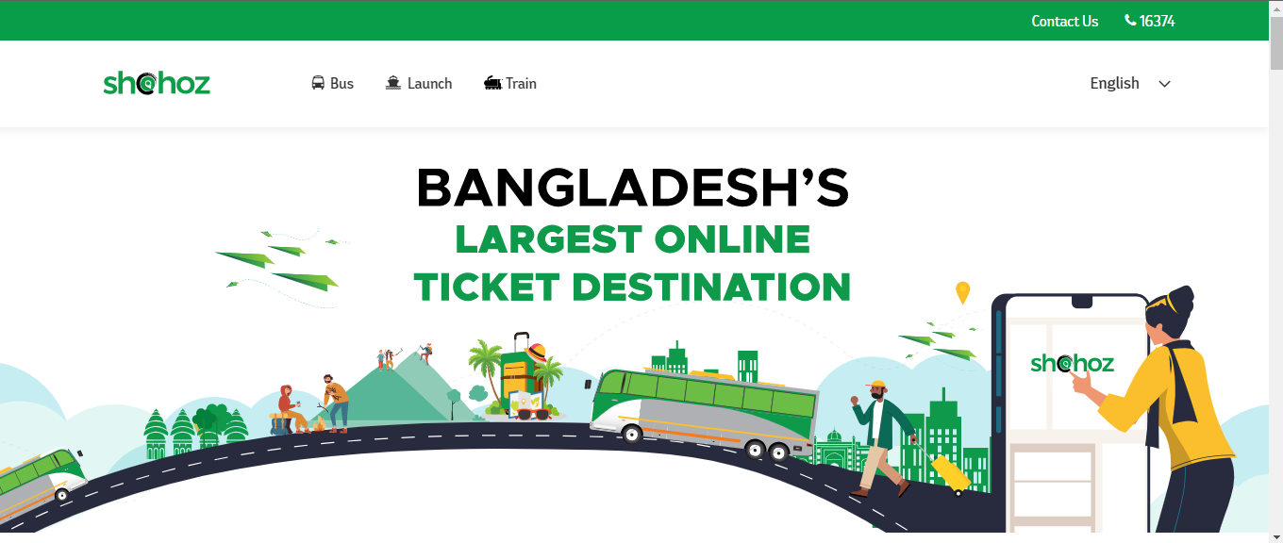

1. Change the language From English to Bangla

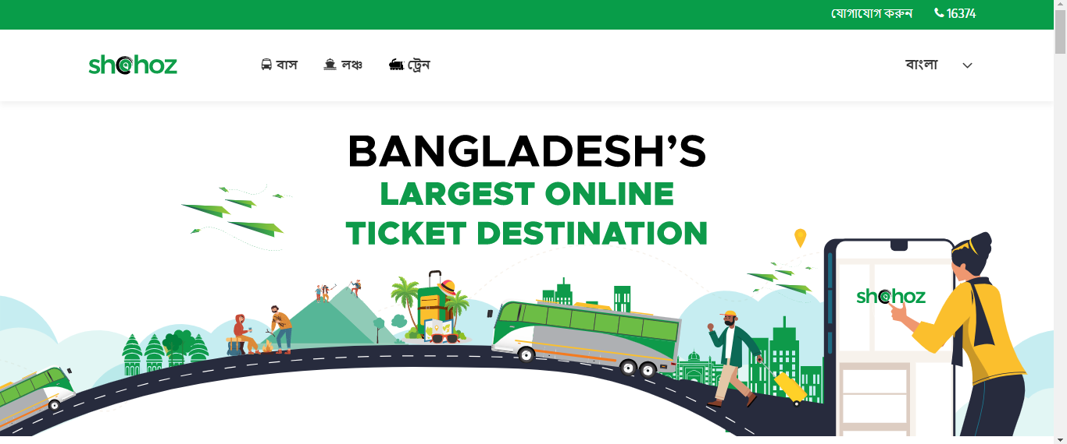

1. But the Contact Number still remains in English

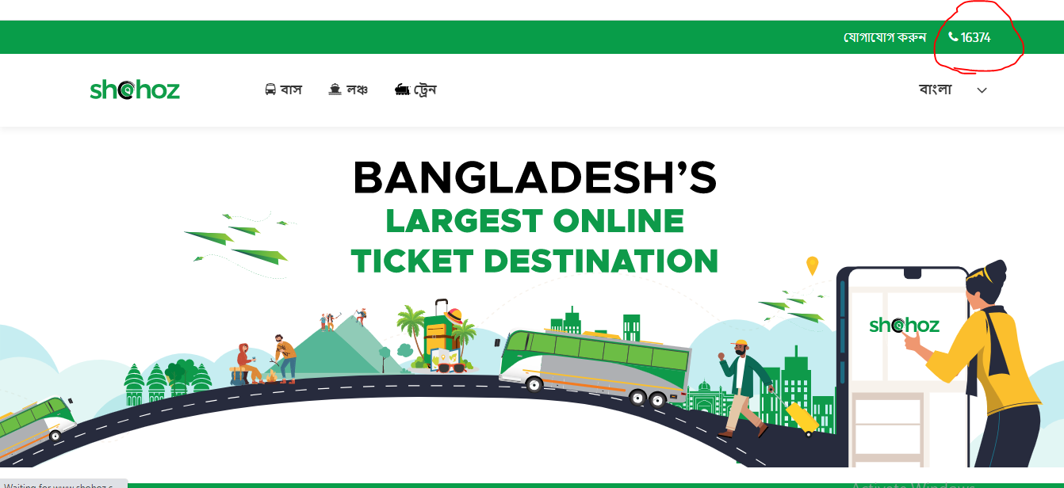

1. Create an issue, consisting of Project name, Issue type, Summary, Description, Assignee, Reporter, and Attachment screenshots of the bug and click on the Create button in JIRA.

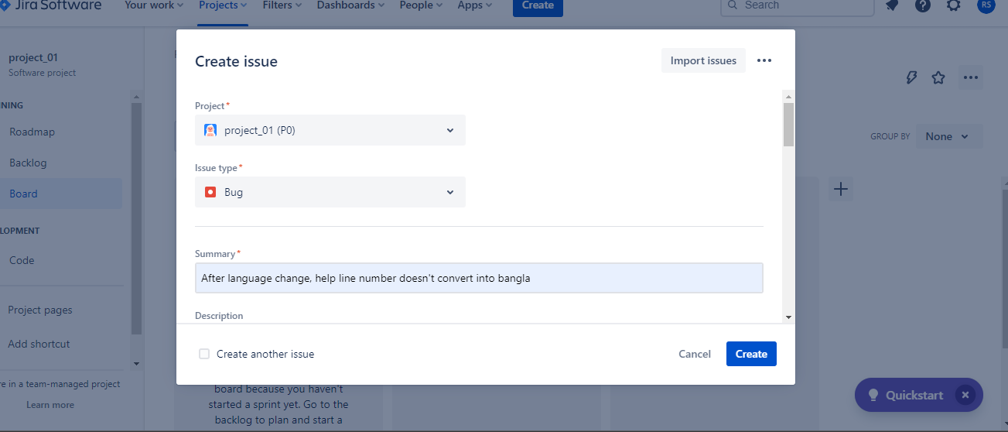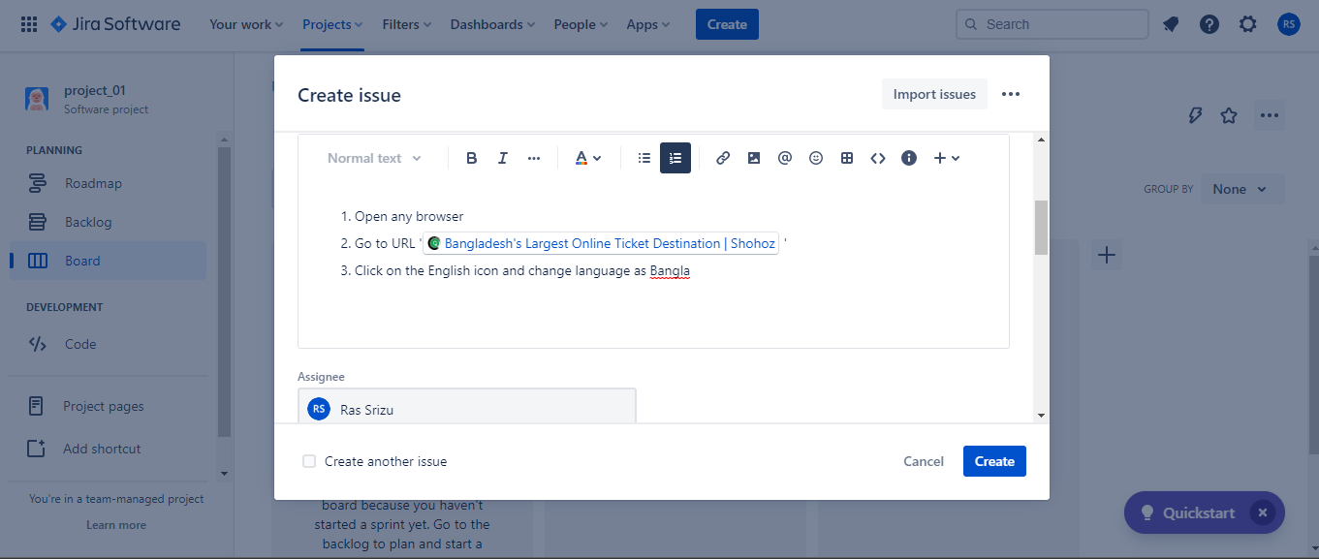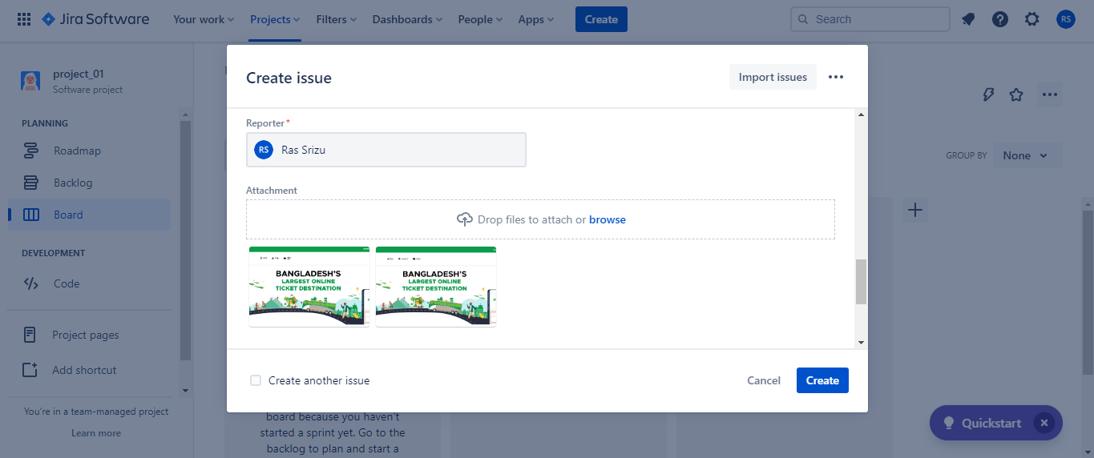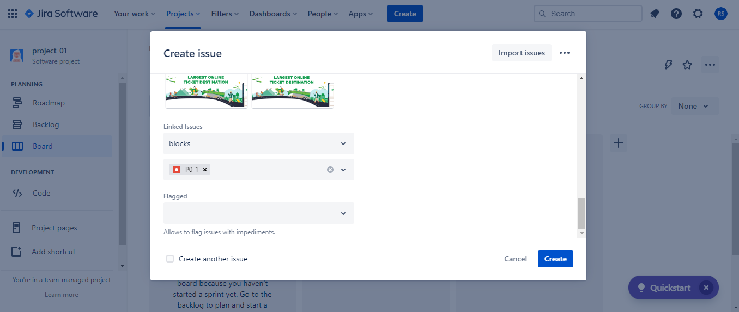

1. Add P0-4 epic

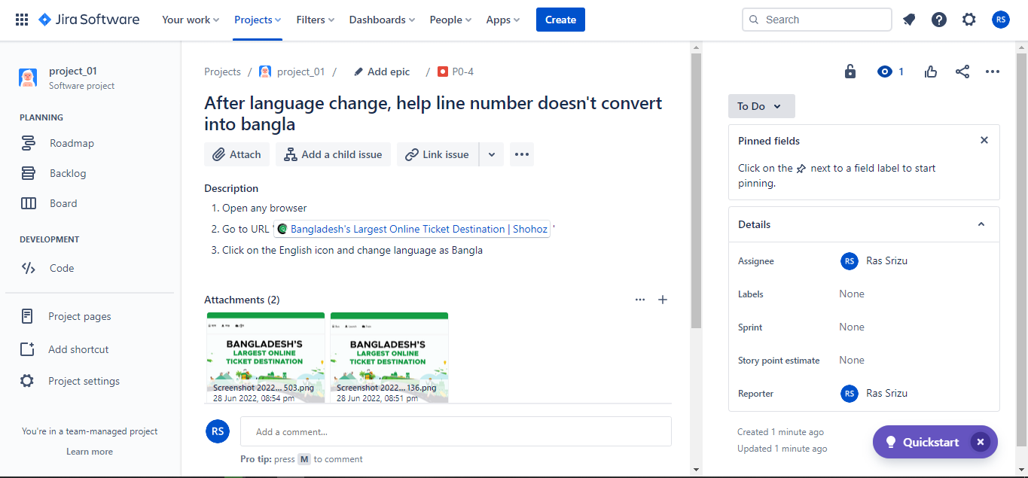

1. Start a sprint

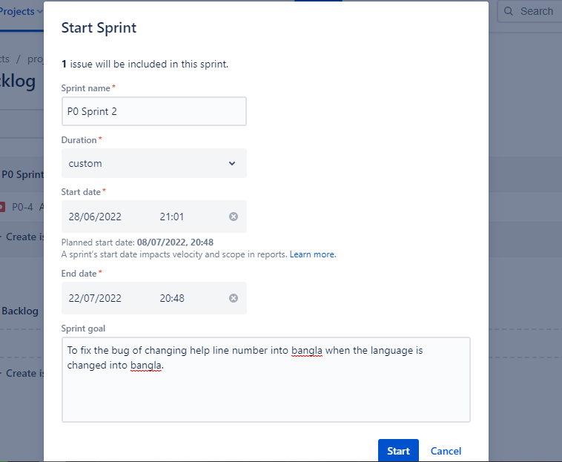

1. Issue the sprint to the developers.

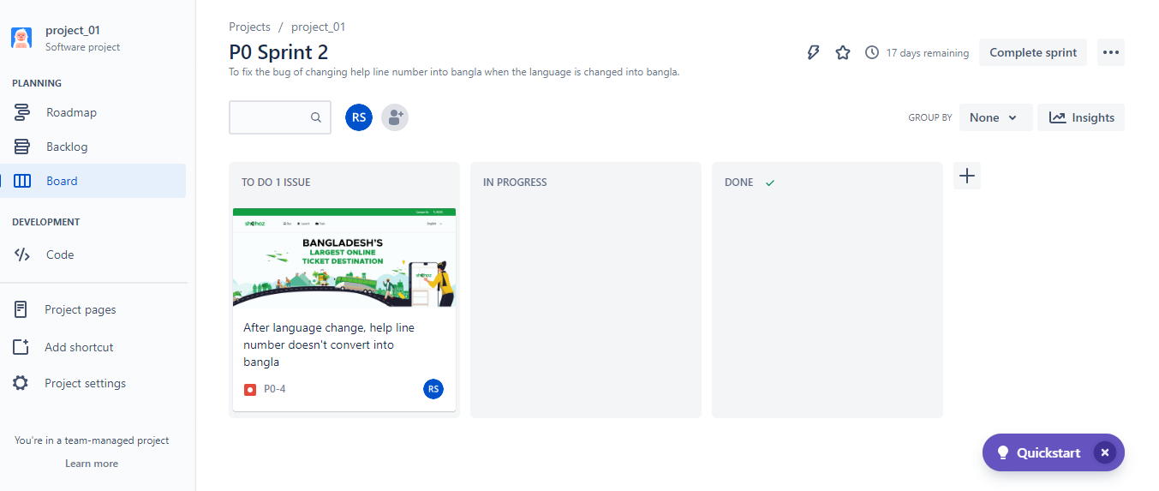

1. In progress

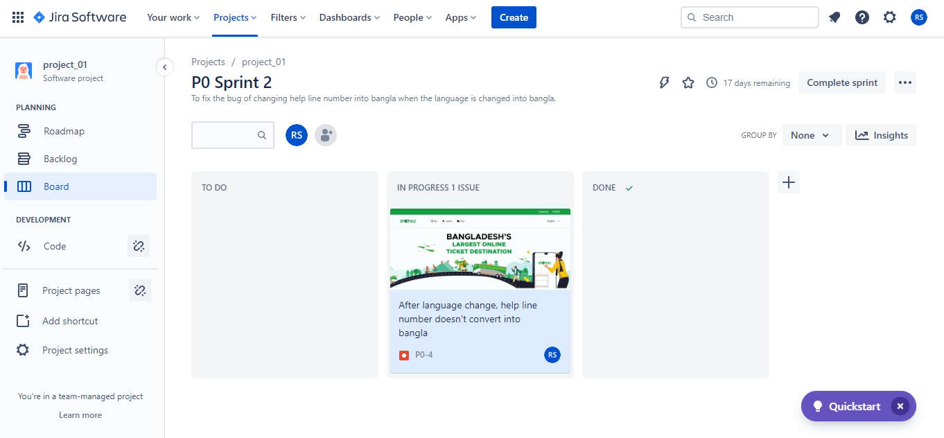

1. Done when the issue is fixed.

